Your First Program

1. Overview

* Your first program, following tradition, will be a simple function to print “Hello World” to the console.
* To do this, you will need basic knowledge of print statements and the structure of a Java program.

1. Setting Up the Project

* You will need to set up a Java project with one class inside it
* If you do not know how to do this, visit the Resources Tab to learn how to set up a Java project in your current IDE.
* When setting up your project, call the project HelloWorld, and call the class Main.
* When you are done setting up the project, your screen should look somewhat like this: (Figure 1)
* Also remember to check the box here when making your class file (Figure 2).

Figure 1, The Ideal Project Window

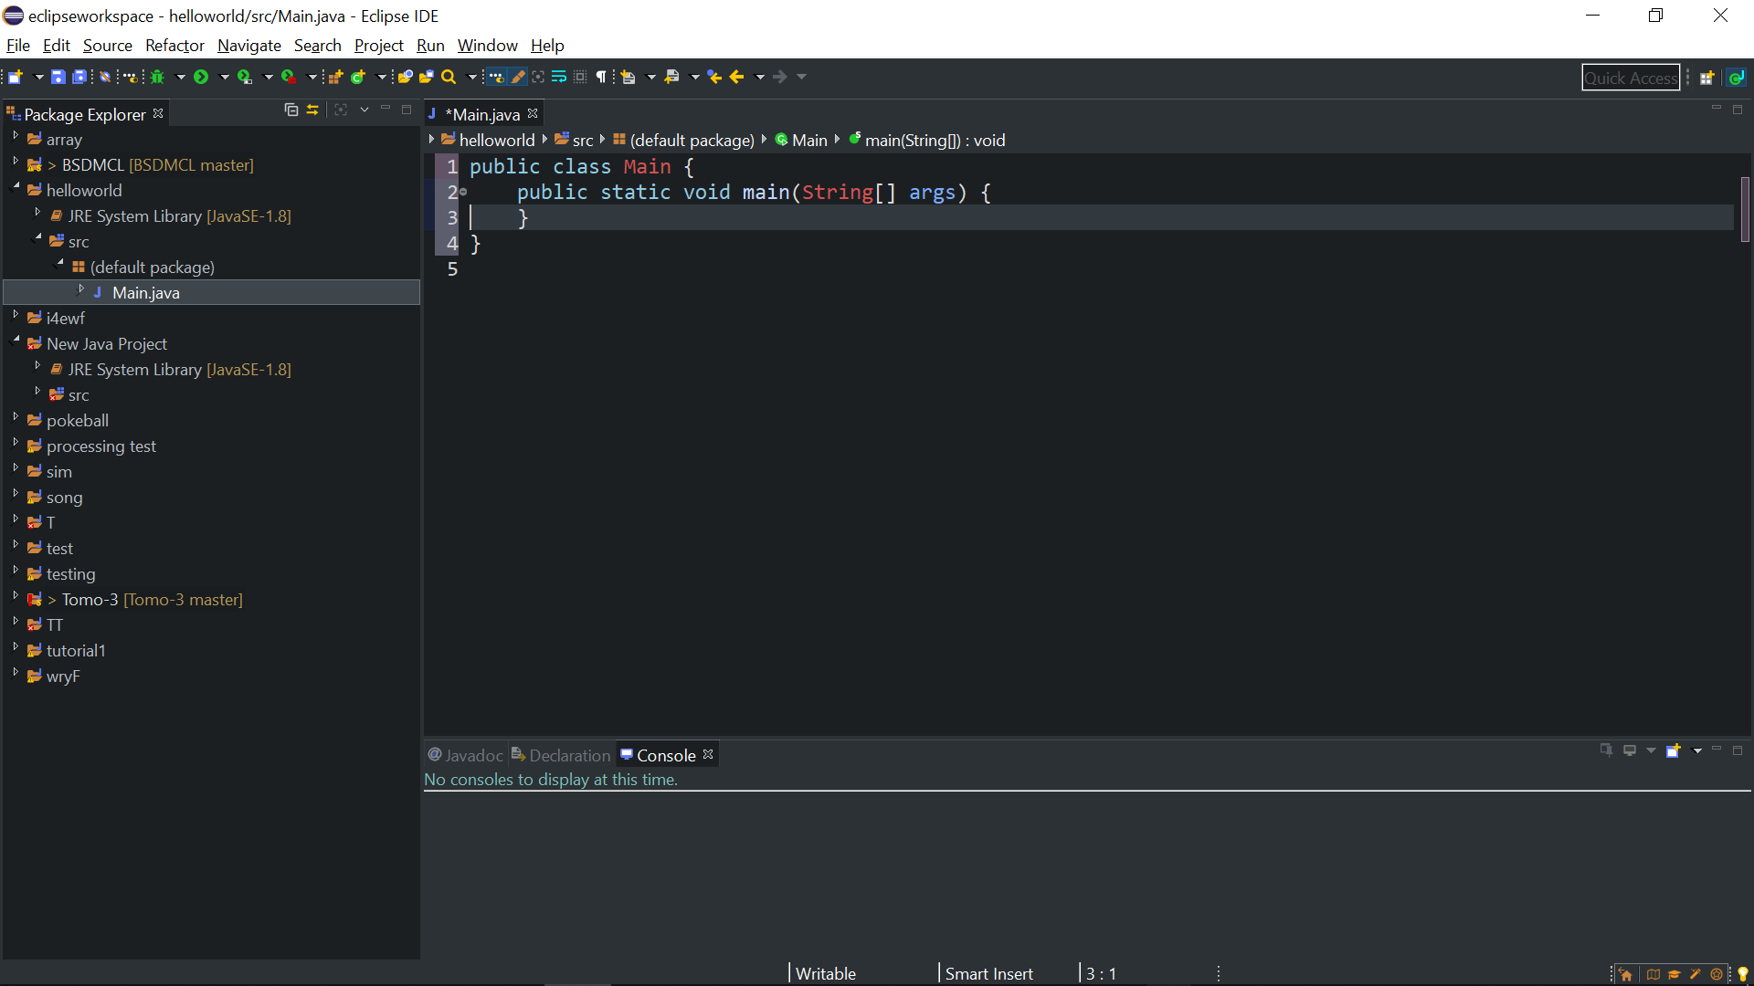

Figure 2, Always Check This Box in Your First Class in a Java Project

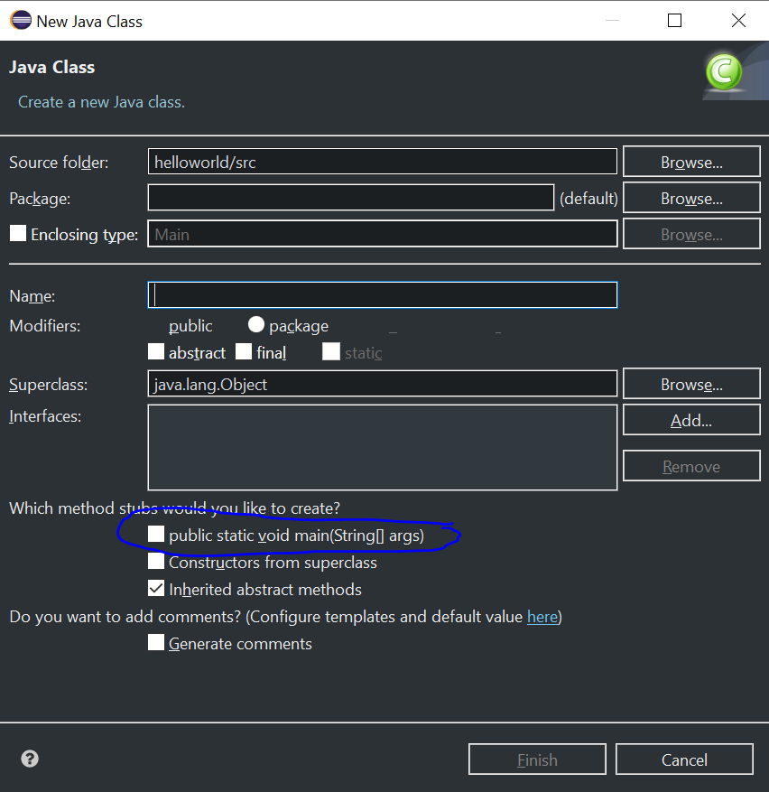

1. The Code

* The code for this project is really simple.
* All you have to do is print “Hello World” inside the main void and run the project.
* If you think your code is done, run the project.
* Remember, you can run a Java project by clicking on the green button in the top left of your screen. (Figure 3).
* If your code is correct, a window should open at the bottom of your screen with the text “Hello World” in it (Figure 4).
* If your code does not run, check a few things:
  + Check for a semicolon after your print command
  + Check that you closed your brackets
* If you have none of these problems, compare your code with someone who has succeeded. If that doesn’t work, ask your lead programmer.

Figure 3, How to Run a Java Project

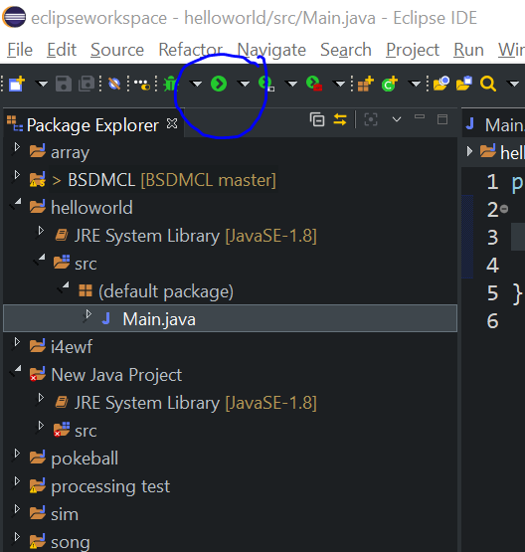

Figure 4, The Correct Output:

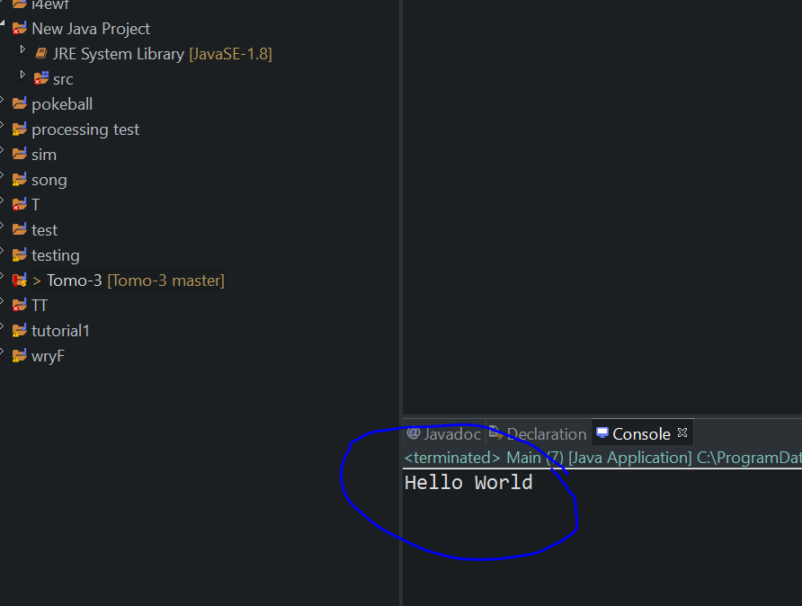

1. Recap

* Congratulations! You just wrote your first Java program!
* This is your first step and it was mine too, not so long ago.